XEQ001 Spec

Description:
Custom Program for RBT Services
Maintenance Screen for Equipment File and Equipment File Notes
Calls XEQ002 to enter Equipment File Notes (this program can be obsoleted once converted)

Files / Table:
- File: EQIUPccc
  - Table: EQUIP
- File: cccEQTXT-V0
  - Table: EQUIP_NOTES
- File: RCMSTccc
  - Table: CUSTOMER_MASTER
- File: OMSHPccc
  - Table: OE_MULTI_SHIP

Options: None

Functionality by Mode:
New Mode:
Menu Path: Run1shot > XEQ001/N
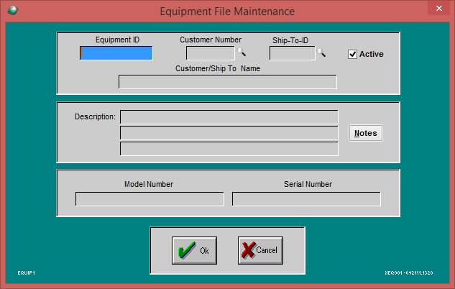
Screen Functions in New Mode:
- Equipment ID Text Field
  - In new mode, enter the ID for the new record to be added.
  - Does not allow duplicate ID’s, this is the Key for the file.
- Equipment ID Browser Button
  - Hidden in New Mode
- Customer Number Text Field
  - Validates customer if manually entered, also populates Customer Name field (see Customer/Ship To Name Text Field)
- Customer Browser Button
  - Opens Customer Browser, after selecting also populates Customer Name field (see Customer/Ship To Name Text Field)
- Ship-To-ID Text Field
  - Validates Ship-To-ID if manually entered, also populates Customer Name field (see Customer/Ship To Name Text Field)
- Ship To ID Browser Button
  - Opens Select Ship To Address Browser, displays additional ship to ID’s for the specified customer, also populates Customer Name field (see Customer/Ship To Name Text Field)

- Customer/Ship To Name Text Field
  - Protected field that is populated based on if a Customer and/or Ship-To-ID is entered:
    - When just a Customer Number is entered:
      - Uses name from CUSTOMER_MASTER.NAME_CUSTOMER
        - Looks up using Customer for CUSTOMER and “1” for REC
    - When a Customer Number and a Ship-To-ID is entered:
      - Uses name from OE_MULT_SHIP.CUSTOMER_NAME
        - Looks up using Customer Number for CUSTOMER, and Ship To ID for SHIP_SEQ
- Description(3 Lines), Model Number, Serial Number
  - Allows entering any info/data
- Notes Button
  - Opens Equipment Notes Screen (if Equipment ID AND Description are not blank)
  - 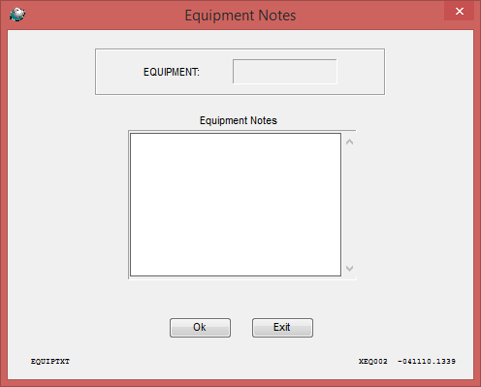
  - Text entered here is saved in the EQTXT file. Note Seq represents line #.

- Ok Button
  - Equipment ID, Customer Number and Description Line 1 cannot be blank.
  - Saves to EQUIP Table,
below is the screen name followed by the Table.Column name where that field is saved.

    - Equipment ID
      - EQUIP.EQUP_NO
    - Customer Number
      - EQUIP.CUST
    - Ship-To-ID
      - EQUP.SHIP_TO
    - Active (checkbox ,defaults to checked)
      - EQUIP.ACTIVE_FLAG (Y or N)
    - Customer/Ship To Name
      - EQUP.CUST_SHIP_TO_NAME
    - Description (Line 1)
      - EQUIP.DESC1
    - Description (Line 2)
      - EQUIP.DESC2
    - Description (Line 3)
      - EQUIP.DESC3
    - Model Number
      - EQUP.MODEL_NO
    - Serial Number
      - EQUP.SERIAL_NO

- Cancel Button
  - Closes screen without saving

Open Mode:
Menu Path: Run1shot > XEQ001/O
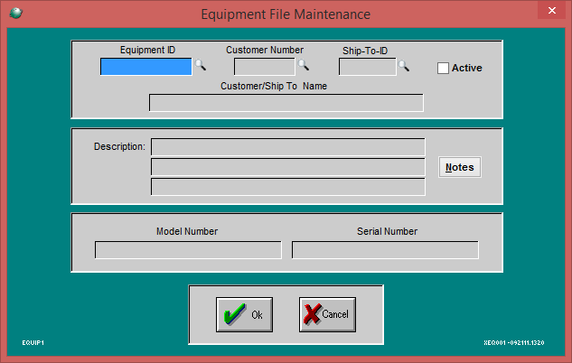
Screen Functions in Open Mode:
- Equipment ID Field
  - Can type in an existing Equipment ID
    - If invalid, gives error message
    - If Valid, Populates the screen with record from EQUIP table
- Equipment ID Browser Button
  - Opens Equipment ID Browser to select existing record
- Active Checkbox, Description(3 Lines), Model Number, Serial Number
  - These can be edited/updated in open mode.
- Customer Number Text Field
  - Validates customer if manually entered, also populates Customer Name field (see Customer/Ship To Name Text Field)
- Customer Browser Button
  - Opens Customer Browser, after selecting also populates Customer Name field (see Customer/Ship To Name Text Field)
- Ship-To-ID Text Field
  - Validates Ship-To-ID if manually entered, also populates Customer Name field (see Customer/Ship To Name Text Field)
  - Validates by checking if record exist in OE_MULT_SHIP using Customer for CUSTOMER and Ship to ID for SHIP_SEQ
- Ship To ID Browser Button
  - Opens Select Ship To Address Browser, displays additional ship to ID’s for the specified customer, also populates Customer Name field (see Customer/Ship To Name Text Field)

- Customer/Ship To Name Text Field
  - Protected field that is populated based on if a Customer and/or Ship-To-ID is entered:
    - When just a Customer Number is entered:
      - Uses name from CUSTOMER_MASTER.NAME_CUSTOMER
        - Looks up using Customer for CUSTOMER and “1” for REC
    - When a Customer Number and a Ship-To-ID is entered:
      - Uses name from OE_MULT_SHIP.CUSTOMER_NAME
        - Looks up using Customer Number for CUSTOMER, and Ship To ID for SHIP_SEQ
- Notes Button
  - Opens Equipment Notes Screen to allow editing notes saved for this record in the EQTXT file, after clicking Ok button it updates record in EQTXT file.
- Ok Button
  - Updates record with changes made to existing record
  - Below is the screen field name followed by where record is saved/updated
    - Equipment ID
      - EQUIP.EQUP_NO
    - Customer Number
      - EQUIP.CUST
    - Ship-To-ID
      - EQUP.SHIP_TO
    - Active (checkbox ,defaults to checked)
      - EQUIP.ACTIVE_FLAG (Y or N)
    - Customer/Ship To Name
      - EQUP.CUST_SHIP_TO_NAME
    - Description (Line 1)
      - EQUIP.DESC1
    - Description (Line 2)
      - EQUIP.DESC2
    - Description (Line 3)
      - EQUIP.DESC3
    - Model Number
      - EQUP.MODEL_NO
    - Serial Number
      - EQUP.SERIAL_NO

- Cancel Button
  - Closes screen without saving

Copy Mode:
Menu Path: Run1shot > XEQ001/C
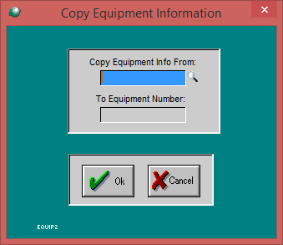
Screen Functions in Copy Mode:
- Copy Equipment Info From Browser Button.
  - Opens Equipment ID Browser
- Ok Button
  - Opens Equipment File Maintenance Screen in open mode with the “To Equipment Number” as the new Equipment ID.
    - Note the new record is not saved until Ok button is pressed in Open Mode Maintenance screen.
    - If notes present in EQTXT
- Cancel Button
  - Closes screen without saving

Delete Mode:
Menu Path: Run1shot > XEQ001/D
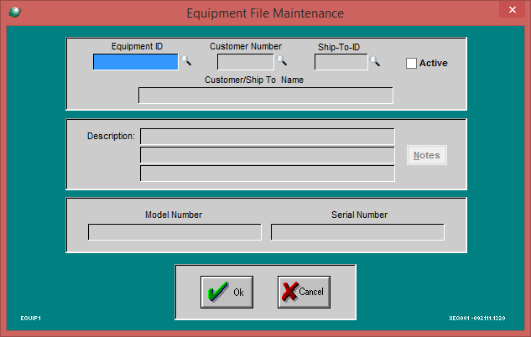
Screen Functions in Delete Mode:
- Equipment ID Field
  - Can manually enter Equipment ID to populate screen with record from EQUIP table
- Equipment ID Browser Button
  - Opens Equipment ID Browser to select ID.
- Customer Browser Button (is this needed in Delete mode?)
  - Opens Customer Browser
- Ship To ID Browser Button (is this needed in Delete mode?)
  - Opens Select Ship To Address Browser
- Active Checkbox, Description Fields, Model Number, Serial Number and Notes Button
  - Protected in Delete mode
- Ok Button
  - Deletes selected Equipment ID record in EQUIP Table
  - Also deletes notes EQTXT File
- Cancel Button
  - Closes screen without deleting

